'Catering for the Olympic Games and Paralympic Games is a monumental task. We want athletes and spectators to have the widest choices of food available and we want that food, wherever possible, to be British.' - London 2012 Chief Executive Paul Deighton
The London Organising Committee of the Olympic Games and Paralympic Games (LOCOG) has outlined a compelling vision for the provision of food at the London 2012 Games. In fact, this provision is so impressive that it has been referred to as the largest peace-time catering operation in the world.
This case study sets out the London 2012 Food Vision and considers its impact of the UK Catering & Hospitality Sector. It then moves a step further to consider the general impact that the Games might have on issues of diet and health for the general UK population.

SUSTAINABILITY ISSUES
In addition to delivering such an extensive and challenging culinary provision, LOCOG will also launch a Food Charter aimed at the Catering and Hospitality sectors, which places sustainability at the heart of its agenda.
'We want to ensure everyone at the Games has a fantastic experience and key to that is the food and drink that’s available – we want it to be affordable, sustainable and celebrating the fantastic diversity and quality of what Britain has to offer. - London 2012 Chief Executive Paul Deighton
Over 14 million meals will be served up to 15,000 athletes across 40 separate locations during the Games, no mean feat! This includes 25,000 loaves of bread; 232 tonnes of potatoes; 82 tonnes of seafood; 31 tonnes of poultry items; 100 tonnes of meat; 75,000 litres of milk; 19 tonnes of eggs; 21 tonnes of cheese and 330 tonnes of fruit and vegetables!
The London 2012 Food Vision will set out benchmark and aspirational standards with regard to food sourcing: LOCOG has set Red Tractor standard as the benchmark standard across meat, fruit, vegetables, salads, cereals and dairy (The Red Tractor is an independent mark of quality that guarantees the food we’re buying comes from farms and food companies that meet high standards of food safety and hygiene, animal welfare and environmental protection.), and all dairy products, beef, lamb and poultry used during the Games must be British.
The London 2012 Food Vision has been developed in consultation with the London 2012 Food Advisory Group, which includes representatives from DEFRA, Food Standards Agency, the National Farmers Union and Sustain: The Alliance for Better Food and Farming.

FAIRTRADE
All bananas, tea, coffee, chocolate and sugar used during the Games will also have to be Fairtrade, meaning that it has been ethically sourced. Any food that could be classified as typically British (such as cheddar cheese) must be derived from British suppliers. Eggs must be British Lion mark free range, and chicken will be RSPCA Freedom Food Certified.
All fish used as foodstuff during the Games must be sustainable. This requires the exclusion of species and stocks identified by the Marine Conservation Society (MCS) as ‘fish to avoid’; also, all wild-caught fish must be caught in a way that conforms to the FAO Code of Conduct for Responsible Fisheries.

TRAINING
Catering staff will be given extra training to ensure that a uniform standard of customer care will be provided at the Games.

Maximisation of Commercial Opportunities
LOCOG will use the opportunities presented by development of the 2012 Food Vision to engage caterers in meaningful dialogue about methods of exploiting the necessary conditions in the Vision in the most commercial viable (profitable) way possible.
Selected caterers will join London 2012 commercial partners Coca-Cola, McDonald’s and Cadbury in the provision of food and drink to consumers, and will retain the rights to be the only food and drink suppliers to sponsor the Olympic and Paralympic Games. Free drinking water will be made available at all Games venues.

FOOD VISION: THE LEGACY
Clearly, the Food Vision for the London 2012 Games is providing a valuable and lasting legacy for the provision of sustainability in the hospitality and catering sector. Peter Kendall, President of the National Farmers' Union (NFU) commented: ‘Never before has such a large scale catering contract had such sustainable procurement standards and I hope that this can act as a blueprint for minimum catering standards in the future.”

A NUTRITIONAL LEGACY: HOW HEALTHY ARE YOU?
Studying the Olympic and Paralympic Games allows us to raise the question of how well the British public might be educated, via the Games, in the importance of healthy eating in their lives. It is clear that development of a healthier, fitter nation is a fundamental goal of the British Government.; for example, The Health Survey for England 2005 indicated that obesity levels amongst 2-10 years olds have increased from 10% to 17% in only 10 years (1995-2005), and have identified a goal to reduce obesity levels back to 2000 levels by the year 2020. Clearly the Olympic and Paralympic Games can play a vital part in achievement of this target.
Olympic gold medalist and London 2012 Sustainability Ambassador James Cracknell 'When you’re an athlete at a Games, you want to know that the right food is available at the right time – it’s a vital part of your preparation. The approach being taken for the food provision at London 2012 is the same for both athletes and spectators – responsibly sourced and ensuring a wide choice.'

This case study now invites interactive and generic considerations of your knowledge of healthy eating, and identifies basic facts and figures that you should be aware of if you are to contribute to the 2012 London sustainability legacy of a healthier population following completion of the Games.

GENERAL NUTRITION: FACTS & FIGURES
This section covers some basics of healthy eating. General guidelines recommend that your daily food intake should consists of a balanced diet of protein, carbohydrates, fibre, (good) fats, fluids, vitamins and minerals in order to be able to function efficiently.
It is generally recommended that individuals intake a mix of protein, carbohydrates, fats, vitamins, minerals, water and fibre on a daily basis. Reference to the food pyramid above offers generic recommendations for a healthy diet: The simple premise is that the foodstuff in the lowest parts of the pyramid (Level 1) constitute the largest part of your diet, progressing up to the highest level (Level 5) that should constitute the smallest part of your diet (as it is the least healthy).

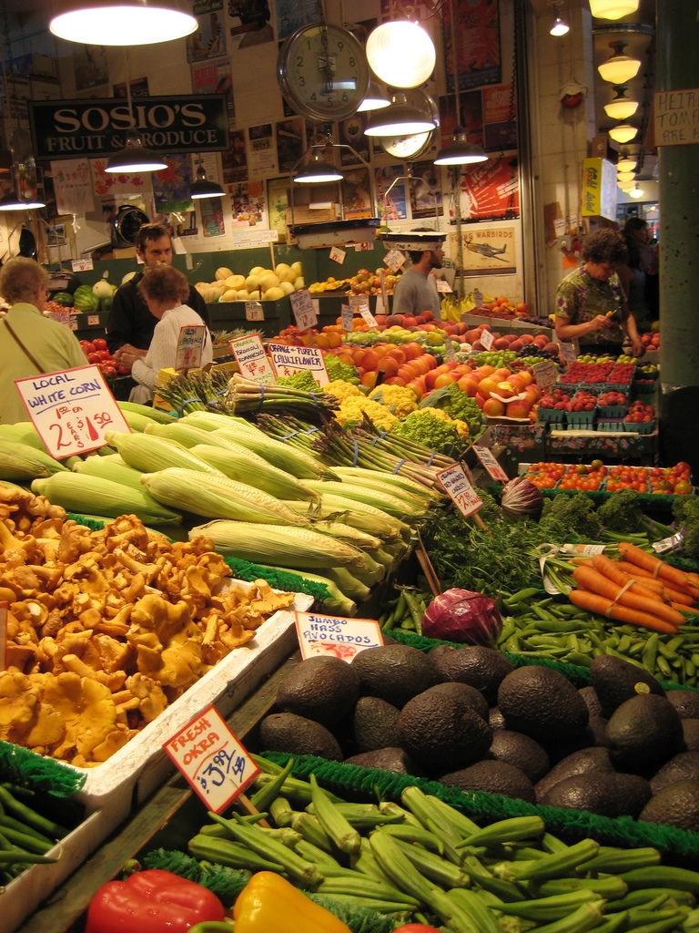
Level 1: Water
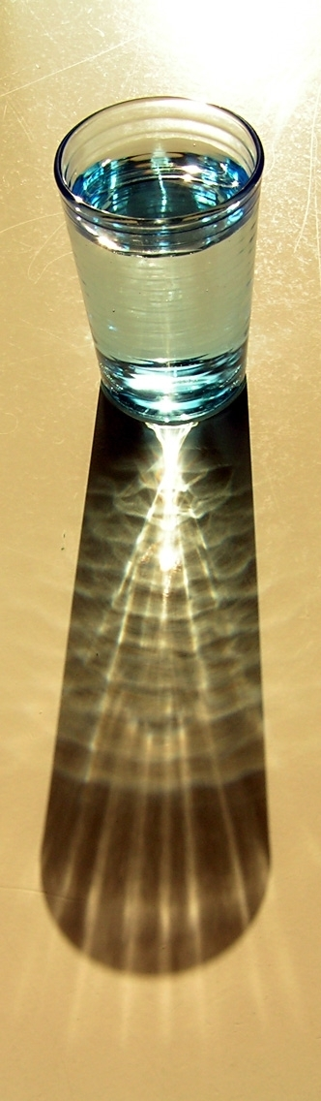
Your body will constantly lose water throughout the day and you must replace this by drinking 2 litres of water a day (either via direct intake of fluids, or via foods with a high water content). When exercising, particularly in warm conditions, it is recommended that you drink 500ml of water 20 minutes before you start, and then drink around 250ml every 15 minutes during exercise, if possible.
Image created by James Tosh and reproduced under a Creative Commons licence.

Lack of water will lead to dehydration, an inability to process toxins or regulate body temperature, and a lowered ability to deliver fuel to working tissue.
Image created by Bohman and reproduced under a Creative Commons licence.

Level two: breads and cereals
Image created by TheCulinaryGeek and reproduced under a Creative Commons licence.

Image created by Rprata and reproduced under a Creative Commons licence.
A strong and fundamental source of carbohydrates, this group should form around 40% of your daily food intake. Foods in this group include bread, biscuits, pasta, rice, breakfast cereals.

Level three: vegetable and fruit
Fruit and vegetables are also a good source of carbohydrates.
This group should constitute around 30% of your daily food intake.

Level four: protein and healthy fats
At least one of your daily meals should contain food from the meat and fish group (if vegetarian, replace meat with soya, pulses, nuts, quinoa). This also includes dairy. Around 20% of your daily food intake should derive from this group.

Level five: fats, oils and refined sugars
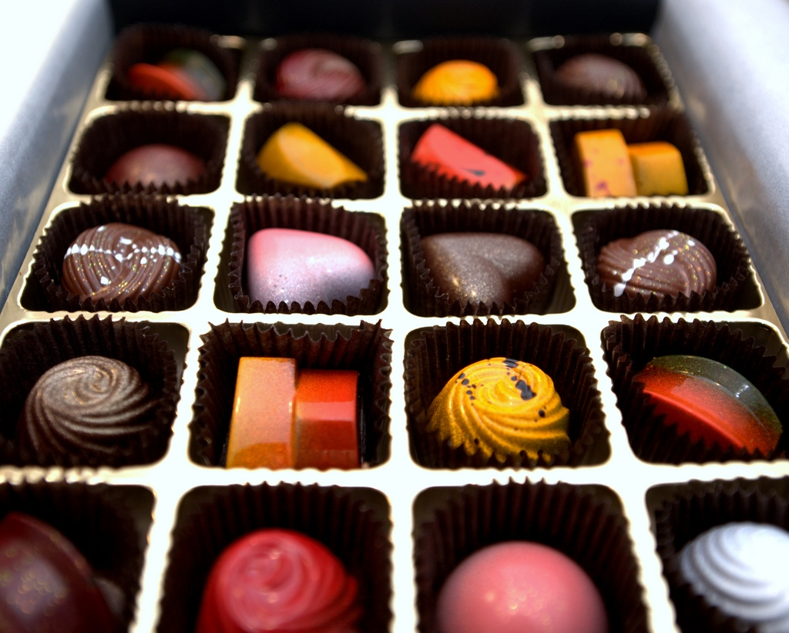
Image created by J Paxon Reyes and reproduced under a Creative Commons licence.
This level constitutes the final 10% of your diet and consists of fatty meat, margarine, sugary sweets and chocolate. Note that this is the only food group that your body does NOT require in your diet! It is only included in this food pyramid because it indicates the level to which you should limit intake IF you are, at any time, tempted to eat this kind of food. Treating Level 1 foodstuff as a treat is perfectly okay, as long as it is limited to a small part of your nutritional intake.

HEALTHY EATING ON A BUDGET
It is surprisingly cheap to eat healthily on a budget. Forget ready meals and packaged food: these are expensive, and usually loaded with sugar, fat and salt. Opt instead for a wide range of vegetables (usually much cheaper if purchased loose), lean meat (turkey, chicken or lean mince are ideal and at least one is usually on special offer in supermarkets, or great deals can be found on larger portions which can be frozen until you need them).

Fizzy drinks, cappuccino’s and other packaged drinks are both expensive and often a substantial source of hidden calories: decrease your consumption of the aforementioned and replace with as much water as possible.

Preparing food at home can save you considerable money when compared to eating out, and also allows you to control exactly what you are eating. Whilst it is possible to calculate the nutritional content of all foods that you cook at home, this is much harder to do in a restaurant.
You don’t necessarily need to invest in expensive protein bars, powders and other sports supplements to push up your protein levels if you are hoping to increase muscular size. A can of tuna can, for example, meet these needs, plus oily fish includes many of the Omega oils that your body requires for effective functioning.

Similarly if you are hoping to lose body fat, you do not need to rely on diet products (which can be expensive and contain disproportionately high levels of salt and sugar). You simply need to ensure that meals are eaten regularly enough to keep your metabolism functioning well (5 times a day, as opposed to the traditional 3), that serving sizes are modest, and that you always include protein, complex carbohydrates, fibre, a source of Omega oils (good fats) and water in every meal.

Image created by obo-bobolina and reproduced under a Creative Commons licence.

COMBATING FATIGUE
If you experience tiredness about 30 minutes after a meal it is very likely that you are eating too much (this is a sign that your blood sugar has peaked and then crashed). If you are tired during the morning it may be because you have not eaten an adequate breakfast. It is extremely important (for reasons of weight management, energy, emotional health and physical acuity and mental acuity) that you NEVER skip breakfast.

OPTIMAL NUTRITION
There is a difference between adequate and optimal nutrition. Elite athletes are aware that a poor or even average diet can detrimentally affect their performance, so they are interested in the achievement of optimal nutriton in their diet.
As athletes place rigorous and habitual physical demands upon their body, they therefore require a much more a scientific approach to food intake than a regular person might. If you are engaged in substantive and regular sporting activity, it is advised that you seek the recommendations of your coach, or a nutritionist or fitness professional for further advice that is specific to your particular sport.

DIET AND EMOTIONAL HEALTH
Whether you play sports, or engage in physical activity on a regular basis, there is much that you can learn from elite athletes. Eating well can exert a tremendous effect on your emotional and physical wellbeing. For example, serotonin (in the carbohydrates that you eat) increases feelings of contentment and wellness. Lack of carbohydrates can make one feel short-tempered and miserable. A healthy diet is also sometimes used in partial treatment of mild depression.
Many people now suffer from varying levels of wheat and dairy intolerances, which can lead to gastric distress and feelings of fatigue. This can wield a significant effect on your mental and physical health so it is important to be aware if any of these dietary issues affect you.
An over-reliance on stimulants such as coffee and energy drinks can lead to sensations of fatigue and lead you to feel drained and cranky; furthermore, an overreliance on sugar and carbonated drinks can detrimentally affect the levels of calcium within your body (particularly detrimental to females given the high incidence of osteoporosis amongst this demographic). There are also an abundance of long term health risks associated with eating a high fat, high sugar diet, such as heart disease and diabetes.

SUPPLEMENTATION
Nutritionists, fitness professionals and other medical professionals vary in their agreements towards the use of vitamin and mineral supplementation in a persons’ diet. Some argue that a healthy, modern diet supplies us with all of the nutrients we need, so supplements are therefore a waste of money. Others believe that due to pollution, stress, chemicals in beauty products and other foods, alcohol, smoking and other factors all contribute to the need to increase vitamins and minerals via supplements to counteract the detrimental effects of these other damaging factors. A multivitamin, and Echinacea (during winter when the common cold is more prevalent), are nevertheless common recommendations.

FIND OUT MORE:
The London 2012 Food vision (PDF, 4.2MB)
http://www.london2012.com/documents/locog-publications/food-vision.pdf

London 2012 Sustainable Sourcing Code
http://www.london2012.com/documents/locog-publications/sustainable-sourcing-code.pdf
Olympic Games website: www.olympic.org

CREDITS
© Oxford Brookes University 2010. oxb:060111:008cs

This resource was produced as part of the 2012 Learning Legacies Project managed by the HEA Hospitality, Leisure, Sport and Tourism Subject Centre at Oxford Brookes University and was released as an Open Educational Resource. The project was funded by HEFCE and part of the JISC/HE Academy UKOER programme. Except where otherwise noted above and below, this work is released under a Creative Commons Attribution only licence.

Exceptions to the Licence
The name of Oxford Brookes University and the Oxford Brookes University logo are the name and registered marks of Oxford Brookes University. To the fullest extent permitted by law Oxford Brookes University reserves all its rights in its name and marks, which may not be used except with its written permission.

The JISC logo is licensed under the terms of the Creative Commons Attribution-Non-Commercial-No Derivative Works 2.0 UK: England & Wales Licence. All reproductions must comply with the terms of that licence.

The Higher Education Academy logo and the HEA Hospitality, Leisure, Sport and Tourism Subject Centre logo are owned by the Higher Education Academy Limited and may be freely distributed and copied for educational purposes only, provided that appropriate acknowledgement is given to the Higher Education Academy as the copyright holder and original publisher.



Reusing this work
To refer to or reuse parts of this work please include the copyright notice above including the serial number. The only exception is if you intend to only reuse a part of the work with its own specific copyright notice, in which case cite that.

If you create a new piece of work based on the original (at least in part), it will help other users to find your work if you modify and reuse this serial number. When you reuse this work, edit the serial number by choosing 3 letters to start (your initials or institutional code are good examples), change the date section (between the colons) to your creation date in ddmmyy format and retain the last 5 digits from the original serial number. Make the new serial number your copyright declaration or add it to an existing one, e.g. ‘abc:101011:008cs’.

If you create a new piece of work or do not wish to link a new work with any existing materials contained within, a new code should be created. Choose your own 3-letter code, add the creation date and search as below on Google with a plus sign at the start, e.g. ‘+tom:030504’. If nothing comes back citing this code then add a new 5-letter code of your choice to the end, e.g.; ‘:01lex’, and do a final search for the whole code. If the search returns a positive result, make up a new 5-letter code and try again. Add the new code your copyright declaration or add it to an existing one.

